Gas Gas Pro SSDT check list.

ALL GAS GAS RIDERS MUST REGISTER WITH GGUK BEFORE THE EVENT.

Please phone Andy Hipwell on 01298 766814 or email him..
andy@gasgasuk.com
Andy will need all your details…..name, address, riding number and credit card details.

- Check spokes in both front & rear wheels for tightness as they may have worked loose since first being checked.
If you have the normal type rear wheel (pre 2011) with the sealing band make sure the sealing band is sealed properly BEFORE the event. Please don’t come to our mechanics on ‘way-in’ day with a leaking rim-tape. GET IT SORTED beforehand.

The latest type rear wheels fitted to 2010 RAGA, and all 2011-2015 bikes have the new band-less rear wheel which prevents the tyre leaking air. You must make sure that the spokes are also in good condition on these wheels.

- Fit new MICHELIN tyres on the front and back. The heat generated on the road destroys tyres and only Michelins stand the abuse. It’s probably better to use the ‘normal’ X11 rear tyres because the new Xlight is very thin on the carcass (crown) so there’s more risk of a puncture.
You can get the whole week out of one rear tyre but we recommend using two.

We also recommend using a thicker Enduro inner tube in the front.
We also recommend fitting new wheel bearings…..particularly the front.
http://www.trialendurodirect.com/products.php?MICHELIN_X11_Rear_Tubeless_Trials_Tyre_097047__228&manufacturers=14

- Repack your silencer with some good quality packing wool. (We recommend SILENTSPORT). It’s a messy job but is well worth doing.
Even if your bike is relatively new we still recommend repacking it before the SSDT. Make sure you re-fit the plastic end can with silicone sealer. And use loctite on the 5mm screws.
Try and not sit on the rear mudguard / silencer because this can make the plastic end can come away from the silencer. You can strengthen this by adding rivets…see pic.
Also a GOOD idea is to add a rivet to the very end of the silencer to help strengthen the fixing of the small stainless outlet.
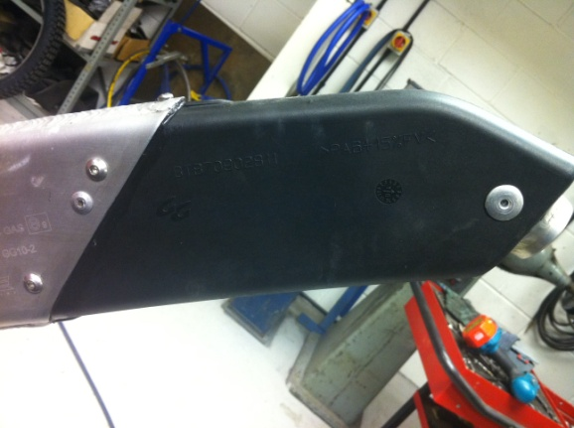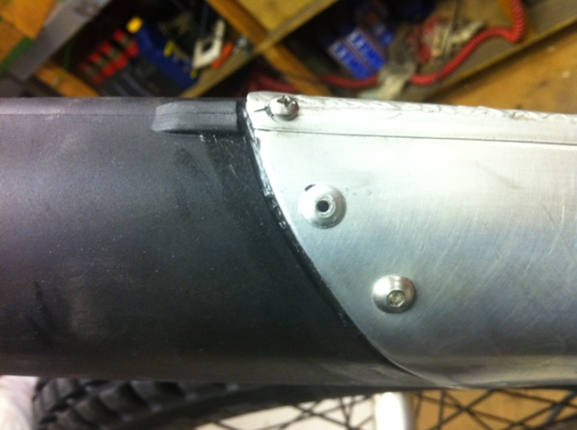
Fit both front pipe & silencer with new o-rings and silicone sealer.
Also check that the middle-box brackets have no cracks….re-weld / repair if necessary.

- Check suspension linkage for excessive play & damaged seals, replace as necessary.
Check your ‘bump-stop’ rubber is intact.

- Clean air filter box & make sure it is completely water tight, clean filter & refit after applying some (decent) filter oil.
On the Pros, it’s a good idea to split the two halves of the air box and seat and re-apply some decent silicone sealant before re-fixing the screws. We use WURTH RTV silicone.

- Also a good idea (but not a must) is to drill a small 4mm drain hole in the bottom of the plastic flywheel cover & put PVC tape around where wires go into casing. Things can be very wet in Scotland and this will help drain any water that may enter your ignition/stator.Whilst the case is off check the flywheel nut.

- Make sure all wiring connections are free from dirt & fitted together properly with silicone grease. If your thermostat switch is working fine then leave it alone. Its a good idea to make yourself a small link wire to bypass the switch and wire the fan direct if the switch fails. Only do this in an emergency because having the fan running all the time eventually destroys the small bearings in the fan motor.

- It’s a good idea also to renew your head o-rings, especially on the two piece S3 cylinder heads. Its also a good idea to carry some head orings in case you cook your bike. If u empty the rad the next thing that fries are the head orings so because they weigh and cost very little, it’s a good idea to carry some.

- Fit new front & rear brake pads.
Tighten ALL the brake banjo bolts especially the rear brake one because they tend to work loose sometimes. Also check the clutch banjo bolt on top of the cover.

- We have had a few problems with the rear brake hose splitting on the 2011/12’s. We have replacement ‘VENHILL’ hoses that are of better quality. Not essential to change but please check yours thoroughly before the event. If worried, get a Venhill hose. http://www.trialendurodirect.com/products/Venhill_Rear_Brake_Hose_for_GasGas_pro_1243.html
The 2013/14’s brake hoses have been modified by the factory and they are fine.
2015 model are also fine standard.

- Renew gearbox oil with 400ml of good quality oil. We also recommend you change it after 3 days. ( we recommend Putoline Light Gear Oil 75w)
http://www.trialendurodirect.com/products.php?PUTOLINE_LIGHT_GEAR_OIL_968&manufacturers=12

- Fit new chain & sprockets and the chain is correctly adjusted & it’s not too low-geared. The standard Pro gearing of 11x41/42 is ok but you may want to gear the bike up a little to help on the road sections. (check those sprocket bolts!)
DO NOT FIT A 12T front sprox on a GG PRO!
Remember ----one tooth on the front is the equivalent to four on the back.
When changing the front sprocket make sure the cir-clip is fitted properly.

- The standard IRIS chains are no good for Scotland. Spend your money on a good quality heavy duty chain like Regina or Renthal for example. (there’s a lot of road work in Scotland). DO NOT USE AN O-RING CHAIN! Also renew the chain tensioner pad.
http://www.trialendurodirect.com/products/Renthal_R1_Trials_Chain_102___104_Link_70.html

- Check the coolant is topped up, condition of the hoses & clips are O.K.

- Remove carburettor & the float bowl, blow all jets out with airline & refit. Usually, the standard jetting is fine for Scotland. A good idea is to change the ‘float jet’ from the std. 200 to say a 300 to allow more fuel when you’re abusing the bike on the road. Sometimes the bigger float jet can affect the performance in the sections running rich and sometimes a smaller pilot jet (33) is needed. Also keep your filter clean and try and stay away from deep water because you’re engine wont like it.

- If you use a Keihin Carb (standard on Racing models) we recommend using the richer slide #3 to make the jetting richer mid range and safter on the road. The #3.5 makes the bike nice and clean in the sections but makes it very weak on the road.

- If you want piece of mine regarding fuel tanks then we do the large capacity ones which all the Team use. http://www.trialendurodirect.com/products/BIG_TANKS_FOR_PROS_53.html This is not just so we can make money either! Its peace of mind for you. You may get stuck on the moors, get lost or your bike might fall over whilst viewing a section. If you use a Keihin carb then these use even more petrol on the road.
If you have a 2013 PRO RACING/REPLICA FACTORY/STD or RACING 2014 model then you must ask for the tank that fits that model because the coil is mounted in a different place and so needs a modified tank.
If you can’t afford a tank then Id advise carrying at least half a litre in your rucksack….which is not actually allowed….oops.
The petrol stops are perfectly situated nowadays thanks to the army and many GG riders manage on the standard tanks.

Hebo also make an auxiliary plastic fuel tank that fits where your front number plate is attached. http://www.trialendurodirect.com/products/HEBO_Auxilary_Fuel_tanks_661.html

- YOU MUST USE THE CHOKE ON THE ROAD. Keep easing off to the ‘rich’ spot is the best technique. Tip; vary your speed and throttle when you are on the road. Holding the throttle in a constant place on any 2 stroke is fatal. The engine will run very weak, detonate and easily seize up.
Always ride a long with a finger hovering the clutch lever. If you feel the engine tighten or if the piston ‘nips’, pull that clutch lever fast ! If you seize the piston, don’t panic. Let the engine cool down a little and try and push the kickstart down. If the kickstart is absolutely solid, you are in trouble ! The cylinder needs to be removed and renewed with a new piston. If the kickstart will push down, you’ve been lucky. Start the bike and carry on, steadily for a while. The engine will rattle but usually quietens down after a few miles.

- Fit new handlebar grips with glue and also wire them on.
There are many grips on the market and we love both the Renthal and S3 Brands.
I would use either Renthal mediums or the new S3 ‘6 Days’ grips
http://www.trialendurodirect.com/products/Renthal_Trials_Grips_110.html
http://www.trialendurodirect.com/products/S3____6D____6_days_asymmetrical_trial_grips_1001.html

- Check all nuts & bolts around your bike.

- It’s a good idea to fit the bigger rubber flaps we can supply…
The bigger tank/airbox rubber flap
http://www.trialendurodirect.com/products/GAS_GAS_Pro_model_airbox_rubber_flap__273.html
The wider rubber flap under the rear mudguard http://www.trialendurodirect.com/products/GAS_GAS_PRO_model_rear_mudguard___airbox_rubber_flap_271.html
From 2011 model onwards we fit a larger rubber ring around the rear shock absorber to help stop water entering the airbox, we have these in stock at GGUK

DON’T forget a front mudguard flap and wider the mudguard with Duct-tape !

- If you normally use a cylinder head spacer kit, then we recommend you remove it for the Scottish. Sometimes these can leak when the cylinder reaches high temperatures for along time (road/moors)
If you are used to riding with a head spacer and want that nice soft power for the Scottish we HIGHLY recommend the new S3 ‘low compression’ head inserts.
http://www.trialendurodirect.com/products/S3__STARS__Cylinder_head_inserts_for_GAS_GAS_PRO250_280_300_863.html

YOU MUST PREPARE YOUR BIKE FULLY BEFORE YOU GO UP TO THE TRIAL
EACH YEAR WE EXPERIENCE PROBLEMS FROM RIDERS WHO DO NOT BOTHER TO DO THE JOBS LISTED ABOVE.
SOME THINGS MAY SEEM UN-IMPORTANT BUT THEY ARE ALL THERE FOR A REASON.
The SSDT committee are quite strict in the paddock regards to anyone else working on your bike so make sure you are able to carry out the work yourself.
Our SSDT service that you register to enables you to use our facilities, buy spare parts and get advice. It does not get you your own personal mechanic for the week.
GGUK services / shop in the paddock open at 9am on Sunday May 3rd.
Our staff will not be there and no parts/service is available on Saturday May 2nd

